FLORIDA CITY AND COUNTY MANAGEMENT ASSOCIATION
Post Office Box 1757 – Tallahassee, Florida 32302 – (850) 222-9684

Home Page: http://:www.fccma.org

MANAGER

The
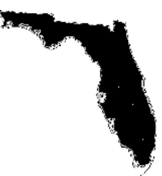

FCCMA

May 2012
Vol. 34, No. 5 5

In This Issue
Monthly Member Profile
Planning for the Future of DeLand: DeLand 2050
FCCMA Annual Conference
May 18 Webinar

Annual Conference in two weeks! Don’t miss it!

Braggin’ Rights
By Lynn Tipton, Executive Director

Florida was the first state association to lead the nation, and then the world, in ICMA Credentialed Managers. From the beginning of the credentialing process, we led the way. We’ve lost that braggin’ right to North Carolina –and I want to challenge each non-credentialed manager to help us change that! Firstly – are you eligible to be a credentialed manager? If not, I hope one day that you will be eligible and want to pursue this distinction. Secondly, if you are eligible, what’s holding you back? I know it is a substantial time commitment, or maybe you think there’s too much paperwork. I’ll agree the early format led to lots of questions, but the process is pretty streamlined and accessible, and we’ve Floridians as advisors to those going through the process – just a phone call or e-mail away. We also have regional training events year-round to help you earn your hours, along with ICMA Practices-based workshops at the annual conference and Winter Institute. You can read books and use on-line programs, too.

Why should you want to be credentialed? In these tough, competitive times professionals need to stand out to employers. We see more and more advertisements referencing “ICMA Credential” preferred, and I don’t believe that will change. Also, it gives you a performance measure against which you can continue your commitment to lifelong learning and to staying current in the field.

If you have any questions about credentialing and the process, start with this web page at the ICMA site: http://icma.org/en/icma/members/credentialing . Amanda Relyea at ICMA is the credentialing manager, and also the best contact point: her number is (202) 962-3565 and the e-mail is credentialing@icma.org or arelyea@icma.org

Let’s get Florida back into first place! North Carolina started emphasizing this a few years ago within its membership, and those folks really rose to the challenge – I know we can rise to the top once more!

Monthly Member Profile
By Michael Grebosz, Assistant to the City Manager of DeLand, FL

- Interviewee:
  - Faith Miller, City Manager of Deltona, FL

- FCCMA member since:
  - October 2008

- ICMA member since:
  - October 2008

- Please describe your areas of formal/advanced education:
  - Master’s Degree in Public Administration, Univ. of Central Florida (1999)
  - Bachelor of Arts Degree in Public Administration, Univ. of Central Florida (1993)
  - Master Municipal Clerk (MMC) designation, International Institute of Municipal Clerks (2000)
  - Leadership Deland Graduate (1996)

- What got you interested in public service?
  - After a change in family circumstances and relocating to Florida from Michigan in 1985, I was working as a Medical Records Secretary and answered an ad and was given the opportunity to be Deputy City Clerk for the City of Palm Bay. Learning more about City operations from the inside of a large relatively new City, I saw this chance as a good time to advance my career by going to college through Pell grants & later financial assistance from my employers. Although it took a number of years as a single parent working full-time, I was finally able to obtain my Master’s Degree and take on more advanced responsibilities progressing through three Cities.

- Current occupation:
  - City Manager, City of Deltona

- Brief job description:
  - Day-to-day management of all departments/services to support the 2nd largest City in Central Florida – a bedroom-community of over 86,000 residents - reporting to an elected body consisting of a Mayor elected at large and (six) City Commissioners elected by district.

- Describe your typical day:
  - Up early responding to emails before even coming into the office; then meetings with staff, constituents, and elected officials both in the office and out in the community; answering more phone calls and emails, letters of concern from residents, and dealing with customer issues; then more meetings and/or emails in the evenings, and attending community events on the weekends.

- Favorite part of the job:
  - Providing quality special events for our residents and helping the community discover its “sense of place.”

- Least favorite part of the job:
  - Dealing with difficult & often sensitive personnel issues; and the difficulty of having seven different bosses who may often have differing views and opinions of how their policy directives are to be implemented.

- Most memorable experience on the job so far:
  - Being in the infancy stages of two newly incorporated cities and basically starting a local government from scratch - City of DeBary (incorporated 12/31/93, starting population of about 9,000) and the City of Deltona (incorporated 12/31/95 with a starting population of over 50,000).

- Hobbies and interests:
  - Spending time with grandchildren, traveling, volunteering as a puppy raiser of Golden Retriever service dogs, camping, reading, baking and visiting art shows.

- Family details:
  - One son, two grandchildren - girl (age 6) and boy (age 3), and 4 dogs

- If you could give one piece of advice to young people interested in a career in public service, what would it be?
  - Remember that the community’s residents are often your neighbors and co-workers and be open to listening to their concerns and understanding that they do not always totally grasp the concept that the City does not have the funds necessary to fix every problem immediately and have the patience to explain what you and the City can do to help.

- Who were your mentors?
  - Alice Passmore, City Clerk, for the City of Palm Bay who gave me my first opportunity in local government; and Richard Diamond, former City Manager for the City of Palm Bay.

- Have you always been in the public sector or have you had experience in the private sector?
  - I worked for Michigan Bell Telephone Company right out of high school for nine years before the divestiture of AT&T and the dividing up of the “baby Bell” companies. Worked for major clothing retailer during high school.

- What career would you pick if you were to pick another?
  - Forest/park ranger, something outside in a milder climate in a locale with four seasons.

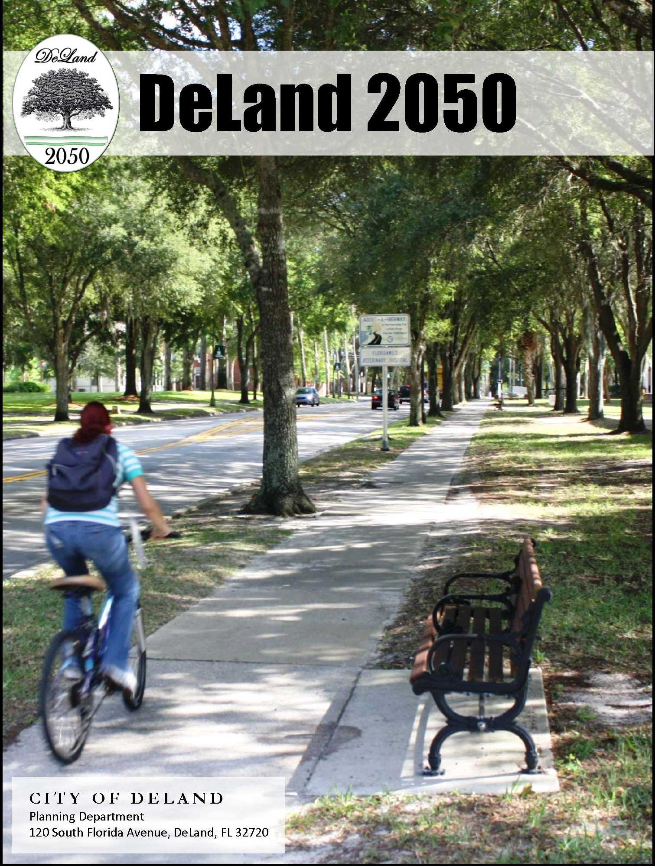
Planning for the Future of DeLand: DeLand 2050
This project will receive the Award for Program Excellence for a population of 20,001 – 50,000 at the FCCMA Annual Conference.

Unique and collaborative planning is something that the City of DeLand is no stranger to. Back in the 1970’s the State Legislature passed the Greater DeLand Act, the purpose was to provide for the health, welfare and safety of the citizens of the area long term, wherein the city could ultimately provide the area with municipal services. In 1995, the city and county entered into an utility service agreement with different boundaries than the Greater DeLand Act connecting the utility service area and the Greater DeLand Act area, thus being referred to as the “Greater DeLand Area” to avoid a proliferation of privately or publicly owned water and sewage operations in the surrounding unincorporated area of DeLand. The city has also participated in many efforts with the county on various items of importance for residents of the DeLand area.

Fast forward to the last decade, the city chose to pursue a goal of becoming a sustainable community. One of the means to become sustainable, a community’s land use pattern must also be restructured away from the typical urban sprawl pattern. Because planning for such large issues can take years to change the mindset that created the existing development pattern, the city wanted to go beyond the typical 10 or 20 year planning horizon.

Looking into the future, the current Greater DeLand Area is expected to double its population by 2050. With major growth anticipated to come from development in the unincorporated part of our utility service area in part because of the new sunrail station, coupled with the shrinking water supply and other stresses that an increased population places on existing services, the city wanted to look at how the development could be influenced to create a more sustainable community. In addition to issues with the water supply, transportation solutions for the new population have to be developed, along with identifying the preferred location for the new population. In short, all development that will occur outside the city limits in the Greater DeLand Area will impact the city, even if there are no immediate annexation plans for the property to come into the city concurrent with development.
In order to plan for the future utility, transportation and other public system needs, the city coordinated a broad-based effort seeking input from business and community groups, schools and colleges, nonprofit organizations, churches and other governments. Growing out of a mutual understanding of the necessity of creating a shared vision for the future of the Greater DeLand Area, the aforementioned ethos is the DeLand 2050 Vision.

The DeLand 2050 Vision Report which was published in November 2011, has assessed the sum of its parts and focuses the community on meeting tomorrow’s challenges. The City of DeLand draws strength from the great traditions of its past, while utilizing today’s innovations to best suit tomorrow’s needs of the community. This vision will enable our city to create a positive, progressive, and sustainable future for the benefit of our children and grand children.

Other award winners will be featured in upcoming issues of The Manager.

FCCMA Annual Conference
Conference is two weeks away! See below for what is happening. You don’t want to miss it! All information is available online at www.fccma.org or email Lynn Lovallo at llovallo@flcities.com.

FRIDAY NIGHT SOCIAL: SUPER HEROES FESTIVAL
Join your fellow caped crusaders for an epic evening of fun, food, dancing, games and more! We will start the evening with a scavenger hunt and the first person who completes the squares will get a prize. Jeopardy is next on the schedule. Each district will have a representative playing so come and cheer on your rep. Hope your rep knows his/her Florida and FCCMA trivia. The winner and runner up will each get a prize. Come prepared to fight crime in your city or county wearing your favorite super hero costume and tell your kids to dress up also. Prizes will be awarded to the best adult and child costume. If you don’t dress up that’s ok, still come enjoy the food, music and fun. Fee included in your registration.

SO YOU WANT TO BE A CITY/COUNTY MANAGER?—WEDNESDAY, MAY 30
A free one-day session on Wednesday, May 30 for anyone interested in the profession. You do not have to be a FCCMA member to attend so if there is someone in your organization who might benefit, send him or her! Lunch is included.

PRE-CONFERENCE WORKSHOP: BEST PRACTICE APPROACHES IN THE NEW ECONOMY—WEDNESDAY, MAY 30, 1:00 – 5:00 PM
Our world has changed and past strategies to add vitality in our cities and towns are failing in a globalized society. Taught by Dave Ivan, State Specialist with the Greening Michigan Institute at Michigan State University, and based on the successful approaches of real people in real communities, this interactive and engaging presentation will provide leaders and citizens with meaningful ideas to position their community for success in today’s new economy. The presentation is a result of nearly two years of research and site visits to more than 65 smaller- and mid-sized best practice communities in 20 states across the country. Registration Fee: $80.
THURSDAY ONLY ATTENDANCE AT THE ANNUAL CONFERENCE
Don’t miss the FCCMA Annual Conference. Even if you can’t attend the whole conference, we have a special one-day conference price of $145.

Thursday begins with the Opening General Session and Futurist Glenn Hiemstra. He will explore future trends as they impact our communities and governance. The big trends – economy, population, energy, environment, technology, food security – influence the future of cities and counties in surprising ways, and offer both challenges and opportunities.

A special Legislative Session is being planned. It will not be the usual recaps of this year’s session, but a look toward the future.

Concurrent sessions begin Thursday afternoon at 2:00: Session 1 - Help Build the Florida of 2032, Session 2 - New Rules for Economic Development and Session 3 – Communicating the Gap Between Employee Benefit Changes and Employer Cost Control Savings. The next round of concurrent sessions begins at 3:45: Session 1 – Ethics: Is There an App for That? Session 2 – Reinforcing Confidence in Government and Session 3 – Biogasification: A Successful Public/Private Partnership with the City of Sanford for Sustainable Biosolids Management.

INSPIRATIONAL BREAKFAST: PERSEVERANCE—THURSDAY, MAY 31, 7:15 – 8:15 AM
Join FCCMA past president and former member-in-transition William Whitson as he relates his experiences during tough times and how perseverance is required for a positive outcome. Registration Fee: $35.

CAREER DEVELOPMENT LUNCHEON: YOUR PROFESSIONAL ROADMAP—THURSDAY, MAY 31: 12:30 – 2:00 PM
Faye Outlaw, County Administrator for St. Lucie County, followed a fortuitous, nontraditional track to the administrator’s office. Her comments, insights and recommendations will highlight a discussion on building your professional roadmap and career plan. Don’t miss this great opportunity to network with other professionals. Registration Fee: $35.

RESUME REVIEW APPOINTMENTS THURSDAY
Are you curious to know if your resume has what it takes to get an interview? Renee Narlock, S.E. Regional Vice President of Bob Murry and Associates Executive Recruiters has agreed to host resume reviews on Thursday. We have had some cancellations so there are a couple of appointments open. To request an appointment with Renee, please email Lynn Lovallo at llovallo@flcities.com.

FINANCIAL PLANNING APPOINTMENTS—THURSDAY AND FRIDAY
It is never too early to review your finances. A certified planner will be at the conference offering free consults. You do not have to be a current participant in a retirement program, but all can benefit from advice on how to plan for your future. Contact Lynn Lovallo at llovallo@flcities.com for an appointment.

May 18 Webinar
The last webinar for this program year will be held on May 18 from 2:00 p.m. – 3:00 p.m. and the topic is Pension Changes for Local Government.

"Local pension plans have been one of the biggest challenges facing Florida's cities in recent years and is clearly an unsustainable financial burden for many cities. Last month, FCCMA members listen to a webinar by Paul Shamoun that explained this issue in detail. This May 18th webinar is the perfect follow-up to Paul's presentation. It will provide valuable information on what three Florida cities have actually done to address this issue. Attendees will learn what obstacles had to be overcome and the process that was followed in each city to gain support for "real pension change" in their cities. This is a must session for city representatives who are wrangling with pension costs and benefits. Panelists include: Florida League of Cities Account Executive – Trust Services Paul Shamoun, St Pete Beach City Manager Mike Bonfield, Naples City Manager Bill Moss, and Hollywood Finance Director Matt Lalla.
All webinars are free. To access the webinars, go to http://florida.acrobat.com/coaching. Select the radio button next to the “Enter as a Guest.” Dial-in: 1-877-685-5350 and the passcode is 461944.

FCCMA Members-in-Transition
The following FCCMA members are currently in transition. Please take a minute to show your support by either emailing or phoning the MITs in your district. A phone call or an email can go a long way to help someone who is temporarily out of work.

You can also help if you have any job opportunities or special projects available for which one of our MITs may be qualified. With the current technology, the project could even be done from the MIT’s home. FCCMA staff has many of their resumes. Please contact Carol Russell at crussell@flcities.com if you need a current resume for one of our MITs.

Also, please keep your FCCMA staff informed of any FCCMA members who may be eligible for MIT status. You can email Lynn Lovallo at llovallo@flcities.com or Carol Russell at crussell@flcities.com.

Larry Arnold
District VI
Former Executive Director-
Community Services of Sarasota County
(941) 840-4223
larnoldz@gmail.com

Robert Bartolotta
District VI
Former Manager of Sarasota
(941) 822-0165
savrobert@comcast.net

Robert Bentkofsky
District III
Former Assistant Manager of Oviedo
(407) 971-6125
rlbentkofsky@bellsouth.net

Matthew D. Brock
District III
Former Manager of Polk City
(321) 507-5096
Matt-brock11@hotmail.com

Stephen J. Cottrell
District VII
(727) 487-3763
stcottrell@gmail.com

Michael Czymbor
Former Manager of Fernandina Beach
District II
(904) 310-6182
mczymbor@hotmail.com

Kenneth Fields
Former Manager of Southwest Ranches
District V
(954) 610-7762
krfields@bellsouth.net

Barbara Lipscomb
Former Manager of Casselberry
District III
(407) 830-7757
Blips50@aol.com

Kathie Margoles
District IV
Former Assistant Manager of Lake Worth
kathiemargoles@bellsouth.net

Jeffrey Naftal
(954) 383-2202
Stout6@bellsouth.net

Frederick C. Nutt
District VII
Former Division Director of Hillsborough County
(813) 792-7811
Fred_libby@msn.com

Markae Rupp
District VIII
Former Administrator of Arcadia
(321) 258-5783
recmngt@gmail.com

Tony Segreto
District II
Former Director of Public Works of Oviedo
(321) 436-7479
tonibuilds@gmail.com

Frank Spence
District IV
Former Manager of Loxahatchee Groves
(561) 640-4908
frspence@bellsouth.net

Susan Stanton
District IV
Former Manager of Lake Worth
(602) 622-0682
susanstanton58@yahoo.com

Bruce St. Denis
District VI
Former Manager of Longboat Key
(941) 650-5054
Saintme53@gmail.com

Donald Stilwell
District VI
Former Manager of Lee County
(239) 334-9301
DDStilwell@embarqmail.com

Dale Sugerman
District IV
Former Manager of Highland Beach
(561) 582-5355
dalesugerman@excite.com

Anita Fain Taylor
District V
Former Manager of Lauderdale Lakes
(954) 854-4240
faintaylor@aol.com

James Titcomb
District IV
Former Manager of North Palm Beach
(561) 315-4302
Jamie@jamestitcomb.com

Ann Toney-Deal
District VIII
Former Manager of Haines City
(863) 422-9242
3anntd@tampabay.rr.com

Oel Wingo
District II
Former Manager of Holly Hill
(386) 299-8755
Owingo50@gmail.com

New Members
The following membership applications have been received. If no current member comes forth with a reason why this applicant should not be approved as a member, they will be invoiced for dues. Matthew Campbell, District VII, Assistant to the City Manager, City of Dunedin, Full Member; Gary S. DeMarzo, Subscriber Member; Enterprise Fleet Management, District V, Doran Veith, Senior Account Executive, Corporate Member; Rachel Glick, District I, Master’s of Public Administration, Florida State University, student member; John Gucciardo, District VI, City Manager, City of Bonita Springs, Full Member; David Hebert, District V, Assistant City Manager, City of Homestead, Full Member; Ricky G. Helms, District VI, County Administrator, Highlands County, Affiliate Member; Douglas Hewett, District V, City Manager, City of Hollywood, Full Member; and Edward Lavallee, District VI, City Manager, City of Venice, Full Member.

Positions
The Manager will no longer print the full ad. All ads are posted online at www.fccma.org under job postings. If you click on the job, it will take you to the full ad.

Systems Analyst — Alachua County Board of County Commissioners — $51,502.46 - $84,979.23 annually. Closing Date: 5/25/12. Please apply on-line at http://www.alachuacounty.us/employment. Please direct inquiries regarding this position to (352) 374-5219. Applicants with disabilities will be accommodated in the application process. Preference in initial appointment will be given to eligible veterans and spouses of disabled veterans. ALL OFFERS OF EMPLOYMENT WILL BE CONTINGENT UPON SUCCESSFUL COMPLETION OF A PRE-EMPLOYMENT DRUG TEST. TDD (352) 491-4431. AN EQUAL OPPORTUNITY EMPLOYER. M.F.V.D.

City Manager — Archer — Pop. 1200. Application packets must consist of seven (7) copies of the following, a resume with a signed cover letter outlining qualifications, a list of Three (3) professional references and a salary history and requirements. Applications will be accepted until the position is filled. Electronic (e-Mail) applications will not be accepted. Applications may be mailed to 16870 SW 134th Ave. Archer FL 32618. Any questions should be directed to the city manager at 352-495-2880 or e-mailed to citymanager@cityofarcher.com.

Assistant City Manager for Operations — City of Coral Gables — Salary and benefits package includes: The annual salary range is $102,356.80-$140,545.60. Salary is negotiable depending on qualifications. Benefits include: vehicle allowance of $450 per month, medical, dental and life insurance, retirement plan, leave allowances, and more. Deadline: Open until filled. To ensure consideration for this position, interested candidates should forward resume, cover letter and five references immediately, via e-mail, to HRD@coralgables.com or fax to 305-460-5518. The City of Coral Gables is an Equal Opportunity Employer/Drug Free Workplace.

Building Director, Development Services Department — City of Coral Gables — Salary and benefits package includes: The annual salary range is $92,851.20 - $127,483.20. Salary is negotiable depending on qualifications. Medical, dental and life insurance, leave allowances, retirement plan and more. Deadline: The position shall remain open until filled. To ensure consideration for this position, interested candidates should forward resume, cover letter, current salary, and five references immediately, via e-mail, to HRD@coralgables.com or fax to 305-460-5518. The City of Coral Gables is an Equal Opportunity Employer/Drug Free Workplace.

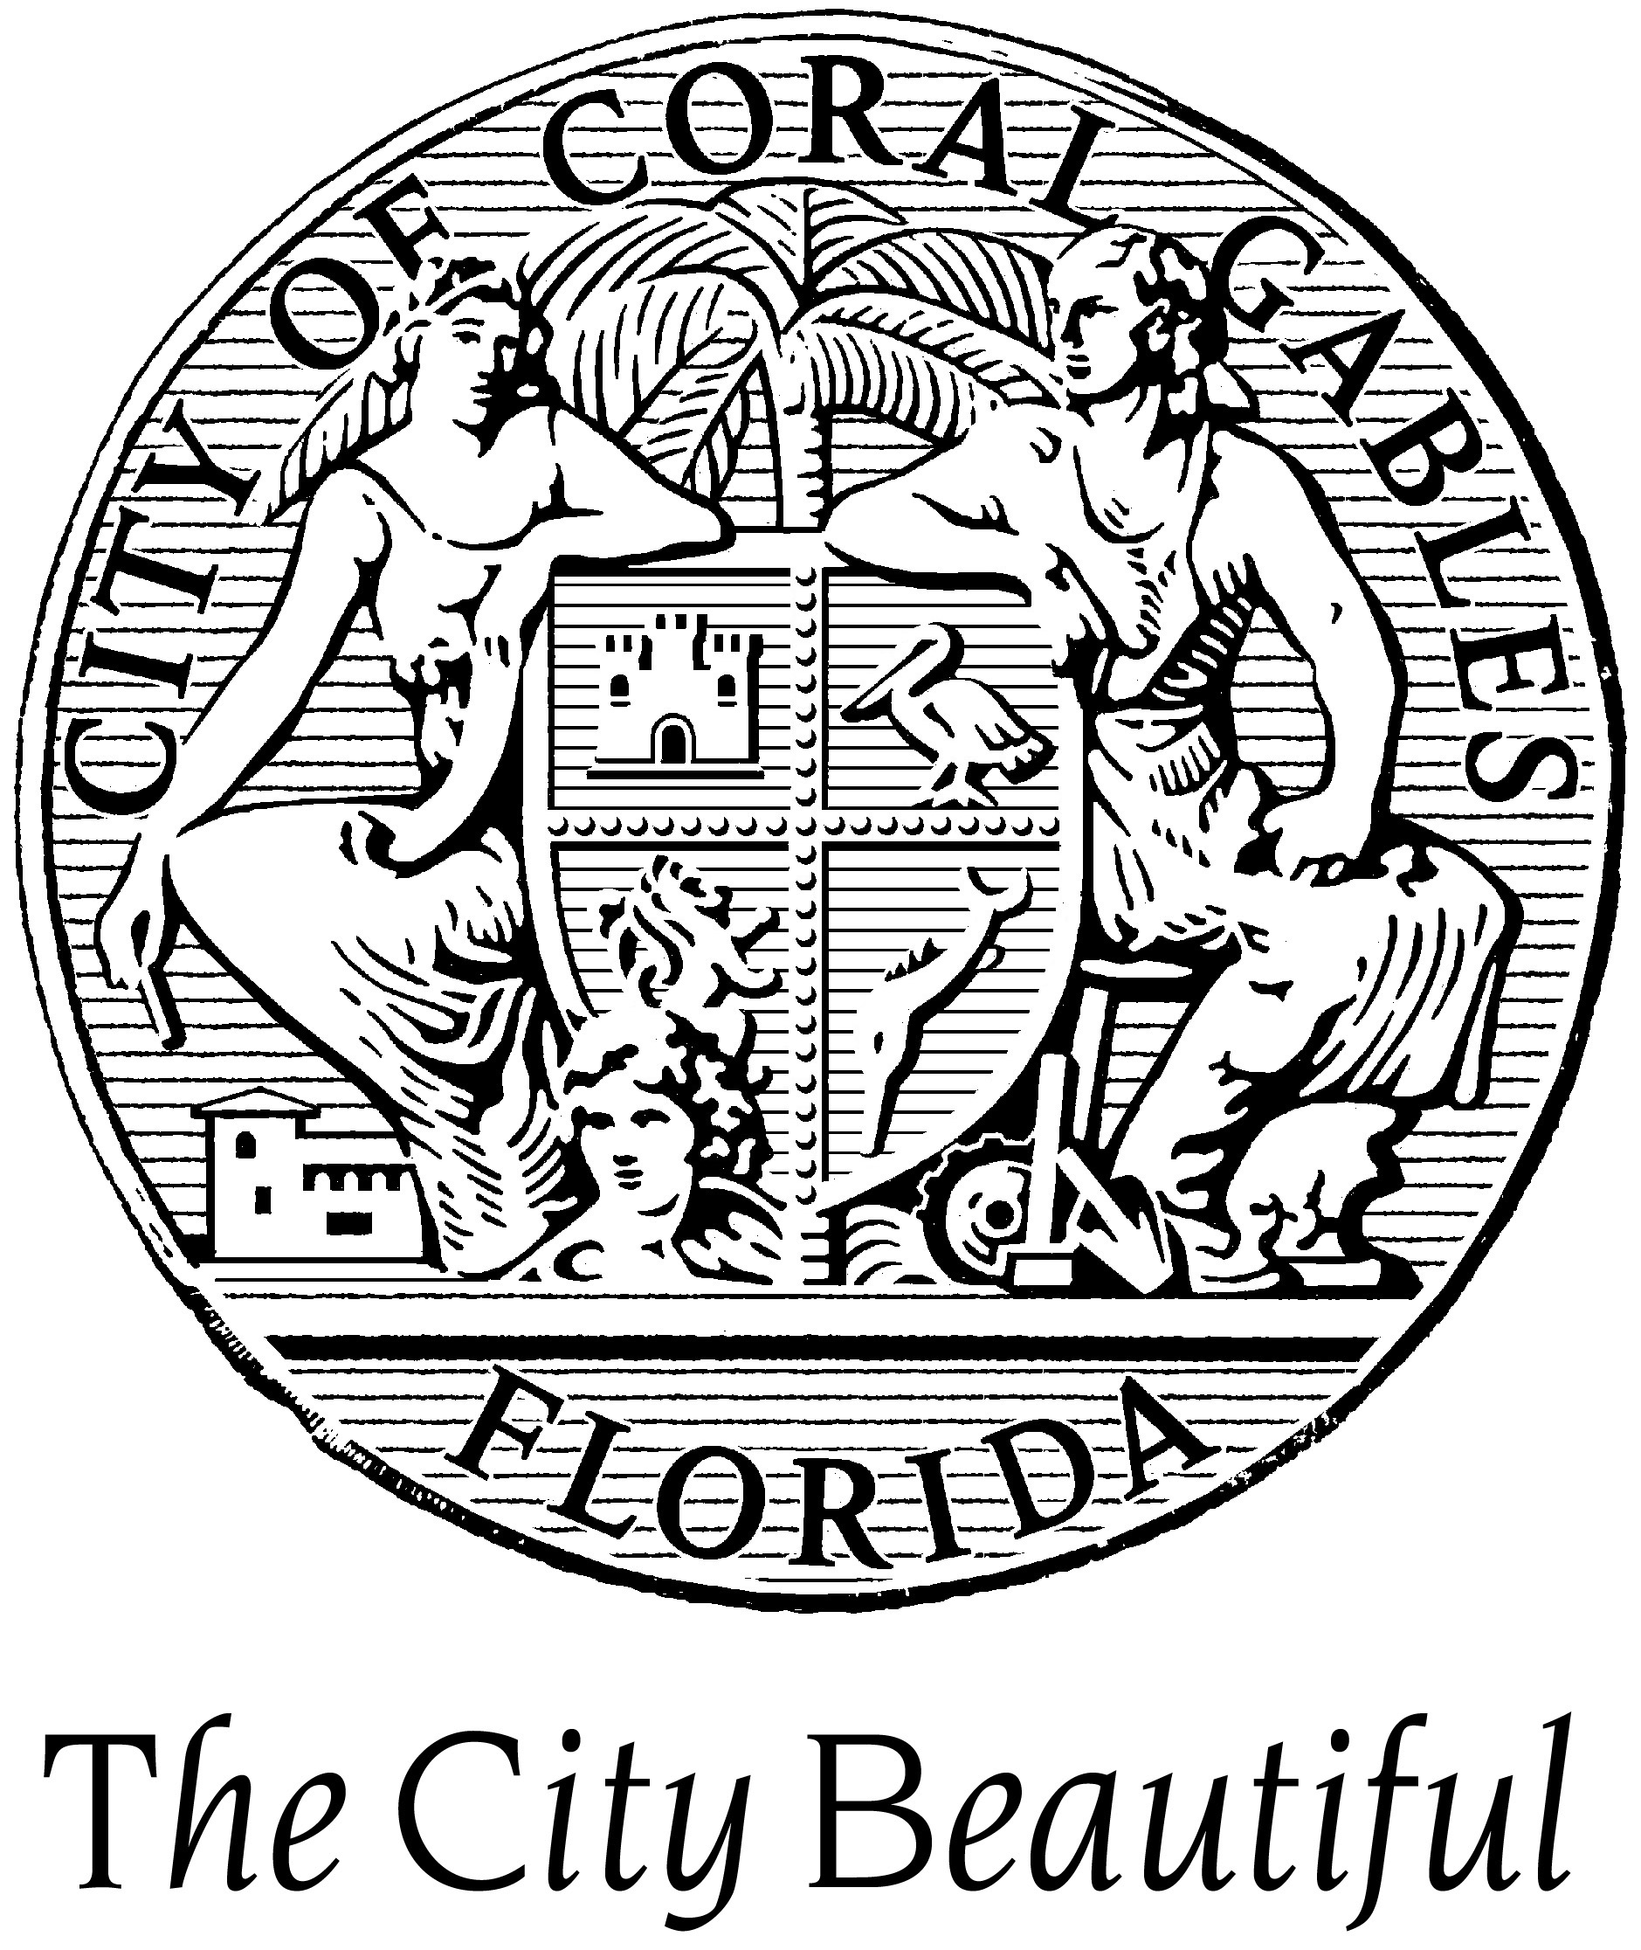
Building Service Coordinator — City of Coral Gables — The annual salary range is $59,862.40- $82,180.80. Salary is negotiable depending on qualifications. Benefits include: Medical, dental, and life insurance, retirement plan, leave allowances, and more. Open until filled. To ensure consideration for this position, interested candidates should forward resume, cover letter, current salary, and five references immediately, via email, to HRD@coralgables.com or fax to 305-460-5518. The City of Coral Gables is an Equal Opportunity Employer/Drug Free Workplace.

Code Enforcement Director — City of Coral Gables — The annual salary range is $65,977.60 to $90,625.60. Salary is negotiable depending on qualifications. Medical, dental and life insurance, leave allowances, retirement plan and more. The position shall remain open until filled. To ensure consideration for this position, interested candidates should forward resume, cover letter, current salary, and five references immediately, via e-mail, to HRD@coralgables.com or fax to 305-460-5518. The City of Coral Gables is an Equal Opportunity Employer/Drug Free Workplace.

Planning and Zoning Director — City of Coral Gables —The annual salary range is $92,851.20 to $127,483.20. Salary is negotiable depending on qualifications. Medical, dental and life insurance, leave allowances, retirement plan and more. The position shall remain open until filled. To ensure consideration for this position, interested candidates should forward resume, cover letter, current salary, and five references immediately, via e-mail, to HRD@coralgables.com or fax to 305-460-5518. The City of Coral Gables is an Equal Opportunity Employer/Drug Free Workplace.

Public Works Director — The City of Coral Gables —The annual salary range is $97,490 to $133,870. Salary is negotiable depending on qualifications. Benefits include: vehicle allowance of $450 per month, medical, dental and life insurance, leave allowances, retirement plan and more. The position shall remain open until filled. To ensure consideration for this position, interested candidates should forward resume, cover letter, current salary, and five references immediately, via e-mail, to HRD@coralgables.com or fax to 305-460-5518. The City of Coral Gables is an Equal Opportunity Employer/Drug Free Workplace.

Utility Services Director — Indian River County Board of County Commissioners —
(Pop. 138,694) Salary: $78,961 - $118,822 DOQ. Open Until Filled. www.ircgov.com/utility-director.

Senior Building Inspector — Lake County — Hourly Rate: $18.99 - $30.38. Closing Date: Open Until Filled. THIS IS A LIMITED TERM POSITION, DURATION UP TO SEPTEMBER 30, 2012. This position is 32 hours per week. Preference will be given to candidates that possess current Electrical and/or Fire inspector certifications. For more information contact: Jeannine Nelson, Employee Services Specialist at (352) 343-9784.

Regional Vice President — Management Partners — Management Partners seeks an experienced local government professional to lead its east practice based in Cincinnati. This is an extraordinary opportunity to continue in the local government management profession from a new perspective. The successful person will have served as a city or county manager as well as exceptional ability to communicate verbally and in writing. S/he will preferably have experience in multiple jurisdictions including a large local government, in more than one state, with strong networking ability. Compensation competitive, DOQ. Email resume and letter of interest to Jerry Newfarmer, jnewfarmer@managementpartners.com or call 513-313-0503.

Risk Manager — Okaloosa County Board of County Commissioners —Annual Salary Range: $50,128.00 - $67,163.20. To apply for this position, visit our website at www.co.okaloosa.fl.us or call (850) 689-5870 for more information. DFW/AA/EOE.

TDC Executive Director — Okaloosa County Board of County Commissioners — Annual Salary Range: $79,913.60 to $135,824.00. To apply for this position, visit our website at www.co.okaloosa.fl.us or call (850) 689-5870 for more information. This position was first posted on May 3, 2012 and is open until filled. DFW/AA/EOE

Public Works Director — City of Okeechobee, FL —Salary range $60-$65,000 with benefits. Full job Description available on our web site cityofokeechobee.com. Request application packet from Lane Gamiotea, City Clerk, lgamiotea@cityofokeechobee.com or 863-763-3372 x 215. Closing Date: Until Filled, First Review, Strongly encouraged to apply by June 15. Successful candidates are required to pass a pre-employment substance screening/physical. EEO/ADA/GINA/VP/DFWP

Diverse Palm Beach County community seeking qualified individual to fill the position of Grants Writer. Under the general direction of the Town Manager, the purpose of the position is to perform specialized professional work involving researching grant opportunities, preparing grant applications and proposals, to enable the Town to attain its goals and objectives established from time to time by the Town Commission and the Town Manager. Bachelor’s degree from an accredited college or university in Public Administration, Communications, English, Business or related field and a minimum of three years of experience as a grants writer are required. Must have knowledge of federal, state, local and foundation grant application procedures, proven record of securing major grants, excellent writing, speaking and presentation skills, extensive experience in research funding opportunities, knowledge of the principles, concepts, methods and techniques associated with computers and on-line research methods, and the ability to establish and maintain effective relationships with department heads, funding agencies and private organizations. Salary $49,857.50 to $71,662.50 DOQ. Excellent Benefits. Deadline: December 30, 2010 or until the position is closed. Submit current resume and completed Release of Information and Contact Information Form to Human Resources Department, Lake Park Town Hall, 535 Park Avenue, Lake Park, Florida 33403. Release of Information and Contact Information Form may be downloaded from the Employment Opportunities page at the Town’s website at www.lakeparkflorida.gov, and will not be accepted by fax or by email. Phone: 561-881-3300. EOE. Top of Form

Public Works/Utilities Director — City of Opa-locka, FL — Posted Date: 11/23/11. Closing Date: Until filled. Salary: Negotiable. The City offers a competitive salary, an excellent benefits packet, and participates in the Florida Retirement System. To apply please send Resume with cover letter & Official City Application Form to: City of Opa-locka, Human Resources Department, 780 Fisherman Street, Opa-locka, Florida 33054; Tel (305) 953-2815; Fax (305) 953-2919. www.opalockafl.gov. Applications/Resumes for this position will be accepted Monday – Friday 8:30 am – 4:30 pm.

Accounting/Fiscal Services Director — Pasco County, FL — Salary $74,000 - $120,301 annually. Closing date: Continuous. ADA/MF/EOE. Apply online at www.pascocountyfl.net.

Assistant County Administrator – Internal Services — Pasco County, FL — Salary – Negotiable. Closing date: Continuous. ADA/EOE/MF. Apply online at www.pascocountyfl.net.

Assistant County Administrator - Public Services — Pasco County, FL — Salary – Negotiable. Closing date: Continuous. ADA/EOE/MF. Apply online at www.pascocountyfl.net.

Budget Director — Pasco County, FL — Salary: $74,000 - $120,301 annually. Closing date: Continuous. ADA/MF/EOE. Apply online at www.pascocountyfl.net.

Emergency Services Director — Pasco County, FL — Salary: $74,000 - $120,301 annually. Closing Date: Continuous. ADA/MF/EOE. Apply online at www.pascocountyfl.net.

Deputy County Administrator — Sarasota County — For Info and to Apply: Please see a complete job description and apply on-line at www.scgov.net/Careers. Resumes may be attached. Only applicants that apply on line will be considered. For assistance, please call (941) 861-5742. Salary commensurate with experience. Excellent benefits include attractive medical/dental/life insurance, generous paid time off, state retirement program, sick child care, wellness programs, fitness centers and much more. Preference in appointment will be extended to eligible veterans and spouses of veterans with documentation of status (DD-214) at time of application. Sarasota County Government is committed to wellness and successful applicants must be tobacco free for twelve months preceding date of application. Drug Free Work Environment EOE / AA / ADAAA

General Manager, Transit — Sarasota County — For Info and to Apply: Please see a complete job description and apply on-line at www.scgov.net/Careers. Resumes may be attached. Only applicants that apply on line will be considered. For assistance, please call (941) 861-5742. Salary: $69,992 - $100,006 (midpoint). Salary may exceed mid-point depending on experience. Excellent benefits include training, attractive medical/dental/life insurance, generous paid time off, state retirement program, sick child care, wellness programs and much more. Preference in appointment will be extended to eligible veterans and spouses of veterans with documentation of status (DD-214) at time of application. Sarasota County Government is committed to wellness and successful applicants must be tobacco free for twelve months preceding date of application. Drug Free Work Environment EOE / AA / ADAAA

Business Developer — Severn Trent Services, St. Augustine — To apply for the position go to www.severntrentservices.com. If you have any additional questions, contact Helen Martinez-Mitcham at (281) 578-4274 or hmartinez-mitcham@stes.com.

Director of Finance — City of West Palm Beach, Florida — Salary Range: $114,194 - $171,547. HOW TO APPLY: If you are interested in applying for this position visit website at www.wpb.org and apply online. OPEN UNTIL FILLED. EOE/DRUG FREE WORKPLACE

City Clerk — City of Williston (Levy County) Florida — Position is open until filled. Salary depends on qualifications. Interested parties are to submit resumes and cover letter to the City of Williston c/o Patrick Miller, City Manager, by mail to P.O. Drawer 160, or 50 NW. Main Street. Williston, Fl. 334696 or by email to Pat.Miller@ci.williston.fl.us.

Zoning Official / Code Enforcement Officer / Flood Plain Manager — Town of Yankeetown — Town's Population: 502. Salary: Send proposed salary to employer. Open until filled. You can mail or bring your resume to the Town Hall at 6241 Harmony Lane, Yankeetown, FL 34498.

Dates to Remember:
May 31 – June 2, 2012—FCCMA Annual Conference, Bonita Springs
June 19-22, 2012—FAC Annual Conference, Orlando
August 23-25, 2012—FLC Annual Conference, Hollywood Diplomat
October 7-10, 2012—ICMA Annual Conference, Phoenix, AZ

