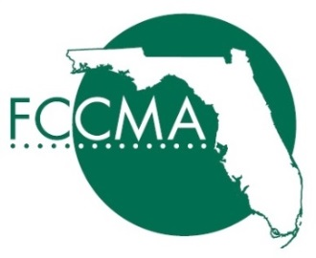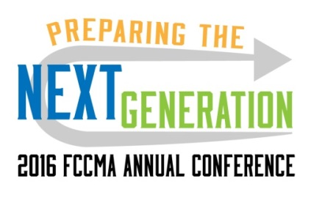

2016 Presentation Request

Programmed into the 2016 Annual Conference, FCCMA will present up to four case studies on Thursday, June 2 and on Friday, June 3 (subject to change).

Each session will be one hour, with an additional 15 minutes for questions and answers and will run concurrently with 2 other sessions. An interactive format with audience engagement is preferred.

All sessions will feature one or more case studies MUST be presented in conjunction with a local government partner. The local government partner does not have to be in Florida and isn’t limited to cites/counties.

Inclusion is the conference, room setup and audio/visual will be provided but participating companies will assume all costs associated with their presentation.
(Travel, housing, specific session marketing, etc.)

Presentation selection is at the sole discretion of the FCCMA Conference Planning Committee. Sessions will be selected by Friday, February 12th 2016.

Companies selected will be required to become a $5,000 Corporate Sponsor.

Submittals must be returned no later than Friday, January 22, 2016
to Beth Rawlins via email at beth@bethrawlins.com

Please submit the following information in a single electronic document. Attachments may also be submitted for supporting materials.

- Company
- Description of Company (20 words or less)
- Project leader/Primary Contact (Name, title, phone & email)
- Corporate co-presenter(s) (Name, title, phone & email)
- Government(s) featured in case study
- Government partner co-presenter(s) (Name, title, phone & email)
- Suggested session title (10 words or less)
- Suggested session description for program (70 words or less)
- Synopsis or Description of project to be presented

Feel free to call and learn more. Beth Rawlins, FCCMA Corporate Liaison (727) 797-9333

