FLORIDA CITY AND COUNTY MANAGEMENT ASSOCIATION
Post Office Box 1757 – Tallahassee, Florida 32302 – (850) 222-9684

Home Page: http://:www.fccma.org

MANAGER

The
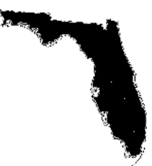

FCCMA

June 2012
Vol. 34, No. 6 5

In This Issue
Super Scott Reflects on FCCMA Membership
There’s No Money For That!
Highlights of the FCCMA Annual Conference
FCCMA Thanks the 2012 Annual Conference Sponsors
2012 Awards and Recognitions
PY2012 – 2013 FCCMA Board of Directors

The Value of Membership; the Value in Membership
By Lynn Tipton, Executive Director

How wonderful to see so many of you in Bonita Springs earlier this month! We have received great feedback on the conference (congratulations to the planning committee!) and on the facility. Be sure to mark your calendar for next year: May 22-25 at the Hilton Orlando.

One of the continuing discussion subjects for your board of directors and staff is ensuring that FCCMA is a good value to members. Surveys indicate that most members agree; however, we are finding that membership categories can be a problem at times. This column will discuss the philosophy behind the categories, and I hope it will bring clarity to the issue.

A Full member is someone who is the full-time, appointed chief administrative officer of a municipal or county government. (This includes deputy, assistant, administrative assistant or equivalent, appointed by the chief administrator and having significant general administrative responsibilities.) A full member has voting rights and may serve on the board of directors after serving three years as a manager in Florida. As members achieve eligibility, staff will notify the individual that the member’s category has changed; however, sometimes the member opts not to change. The reason is often financial because full members pay a higher level of dues. If the member wants to remain at the current category due to the dues cost, the member will need to submit an appeal to the Membership Committee stating the reason not to change. As Florida’s economy suffered in the past six years, so have the membership rolls of many associations. While we appreciate that many members are now paying their own dues and that local governments have greatly limited which associations may be joined by employees, we are hopeful that members want to rise in their categories so they can vote, become more active, and take on leadership roles.

Affiliate members do not qualify for full, but are working in the profession or for a non-profit agency, special district government, university or association. As indicated above, affiliate members are expected to become full as their careers advance. Affiliate dues may be paid quarterly if they are paid by the individual, not the city.

Corporate membership applies to companies, not individuals, and most corporations who choose to be members do business with local governments in Florida.

Life members are those who have retired and wish to stay active in the profession. This category used to be called retired member, but the term was changed in May 2012 to better reflect a member’s commitment to the profession.

Student member is a growing category that attracts undergraduate, graduate and post-graduate students in several fields – primarily public administration. Membership can help these students learn about the profession and network with members at various events.

Subscriber is the category designed for those who want to receive association materials but who either live out-of-state or are not eligible for other categories. Subscribers cannot serve on committees and do not usually attend FCCMA trainings or events.

Honorary Award, formerly “membership,” was changed to an award effective May 2012. A member or non-member having made extraordinary contributions to the profession can be considered for the Honorary Award. This is now under the purview of the Awards Committee.

All FCCMA memberships belong to the individual except corporate.

You will find that FCCMA’s categories are similar in qualification to those of ICMA; however, the terms are different. ICMA refers to professionals as corporate members, for example, and uses a vendor term for its business-related members. Both associations have the same goal with regard to its full or corporate levels: that this level represents the most active participants, those who seek and find the greatest value in membership, and those who wish to vote and take on committee, board, and other leadership positions. If you have any questions regarding FCCMA membership I hope you will contact me, or a member of the Board of Directors, so we can address your concerns.

Super Scott Reflects on FCCMA Membership
By Scott Andrews, Recreation Supervisor, City of Temple Terrace

Hello everyone,

In an effort to generate more interest for the revamping of the FCCMA coaching program I prepared a few words to say at the Friday social. Unfortunately, I was far too busy, and the environment did not seem suitable. However, I wanted to share it with you all. Perhaps, it could be used as a testimonial of sorts on the website, or in an email.


“This time last year I received a scholarship to attend the ICMA conference in Milwaukee. I was very excited to become actively involved in FCCMA/ICMA. I got off the plane in Wisconsin not knowing a single person in the entire state. I headed to the convention center for the “first-timer” ice-breaker. I was discouraged as a very social person to see everyone sitting at separate tables, not conversing with one another. I left this social deflated and sacked of my usual positive attitude.

I was invited to a dinner with the Florida folks that night. I had decided not to go at that point. I did not want to sit through another awkward get together in which I would be the odd man out. At the last moment I chose to make the most of the money I spent to be there, and the vacation days I was using to attend. At the dinner I sat across from Micah Maxwell and Carl Harness. Little did I know at that time that they would become invaluable resources to me in the coming months. As the night went on I met “the Lynns,” and Jon Lewis. They all made me feel welcome and accepted into the FCCMA family.

The next night I was sitting alone watching a game at a restaurant when Michael Pleus invited me to sit at his table as he caught up with another longtime friend and colleague. All of these small gestures went a very long way with me. In the last nine months I have built relationships with all of these individuals, and too many more to mention. I have joined several boards, won an Emerging Leader Scholarship, and now stand before a group of you in a custom made super hero cape. Wow, how things have changed relatively quickly. We should all be aware of the impact that we make on others, particularly those new to the organization. This brings me to my point of the revamping of FCCMA’s existing coaching program

The role of the coach has no boundaries. It could take the form of a mentor/mentee relationship. A coach could simply be a sounding board for ideas, or even just someone to vent to when a job does not go your way. As a high school coach I have learned more about myself by helping others achieve their goals. In the last few months of involvement with FCCMA, I have already learned that you cannot make it to the top, or stay at the top alone. So, on that note I encourage you all to actively participate in FCCMA’s coaching program. Who knows, you may just give another first timer the confidence to stand up in front of the group in a costume this time next year. For details on the coaching program please contact Joyce Shanahan, Michael Pleus, Faye Outlaw, or myself. Thank you again for all of you that have helped me in the past year.”
There’s No Money for That!
This project received the Award for Program Excellence for a population of Under 20,000 at the FCCMA Annual Conference.

Those of us in local government hear the phrase “There’s no money for that!” all too often these days! But, that was the only answer Destin City Council could offer in December 2010 when its ad hoc Recreation Committee recommended the addition of a city dog park to the 2011 Capital Projects budget. There were simply no funds for any capital projects in 2011.

Since all Destin parks are off-limits for dogs, and recognizing that where there’s a will, there’s a way, city councilors envisioned an alternative and assigned the committee a new task in the form of a novel partnership: if the committee could raise enough money from the community by Sept. 1, the city would match those donations up to $30,000 with park impact fees and build the park on city land.


Rather than balk at the challenge, the Recreation Committee immediately set to work and formed a separate Destin Dog Park Committee of citizen volunteers to raise funds for the new park. The amazing success of the community effort, from placing donation boxes in local shops and restaurants, to bagging groceries at Winn Destin Dog Park

Dixie, to four days of free dog sitting in exchange for a $100 contribution to the park – the people involved, the ideas they came up with, and the money they raised has set a new standard for partnerships in Destin.

Suffice it to say that at the committee’s first meeting in March 2011, three months after the “gauntlet” was thrown, the committee had amassed $2,200; by the Sept. 1 deadline, five months later, the committee presented to Council donations totaling $38,928! The public investment and enthusiasm for this project was astonishing.

The city immediately did its part and contributed its monetary match. Beginning in October 2011, in-house personnel and subcontractors installed irrigation, sod, fencing, and amenities. (left to right) Mayor Sam Seevers and community
volunteer and dog park organizer Nancy (Destin Dog)
Weidenhamer

The grand opening of Phase One of the Destin Dog Park took place on Jan. 7, 2012, and includes small and large dog areas with vinyl chain link fencing, new sod and irrigation, water stations, waste stations and a new sidewalk. (Naturally, dogs were invited). In the first week alone, more than 2,200 dogs and their humans visited the park!

The measure of success is evident. Hundreds of dogs and their human pals visit their friends at the park each day. Donations for phase two (to include park amenities such as an agility station, water features, enhanced landscaping and a beach area) are already being offered. An unexpected success is the popularity of the park among Destin snowbirds and visitors. It is becoming increasingly popular to bring pets along on vacation and now our visitors are choosing Destin because of the new dog park. The park is actually helping our economy!

A recent news article quoted a nearby city councilor on the Destin Dog Park, saying “I was absolutely amazed and astounded at the sense of community in that little park. I saw children, I saw elderly people, I saw people from all walks of life, all occupational levels, all co-existing in a safe, comfortable environment.” This recognition adds to the success of the Destin Dog Park and proves that the City of Destin is leading by example.


The residents are so proud of their new dog park for many reasons: it provides a much-needed area for dog owners and their pets to socialize and play; it was born from a grass roots effort and an innovative form of partnership; and it demonstrates the power of community in achieving a shared vision.

The City of Destin is particularly proud of its new Dog Park because it shows community-oriented government at its best. The creative approach used to fund this (left to right) Councilman Tom Weidenhamer, Councilman Jim Bagby,
Councilwoman Sandy Trammell, Councilman Larry Hines, Nancy
(Destin Dog) Weidenhamer, Councilman Jim Wood, Miss Destin Peyton
LoCicero, Mayor Sam Seevers, City Manager Maryann Ustick.

project can serve as a model for all local governments with grander plans than budgets – partner with the community and cost-share!

Other award winners will be featured in upcoming issues of The Manager.
Highlights of the FCCMA Annual Conference
Overall the comments from the conference were great. Even though Bonita Springs was not in a central location, attendance was up from the last few conferences, and the hotel and staff were wonderful.

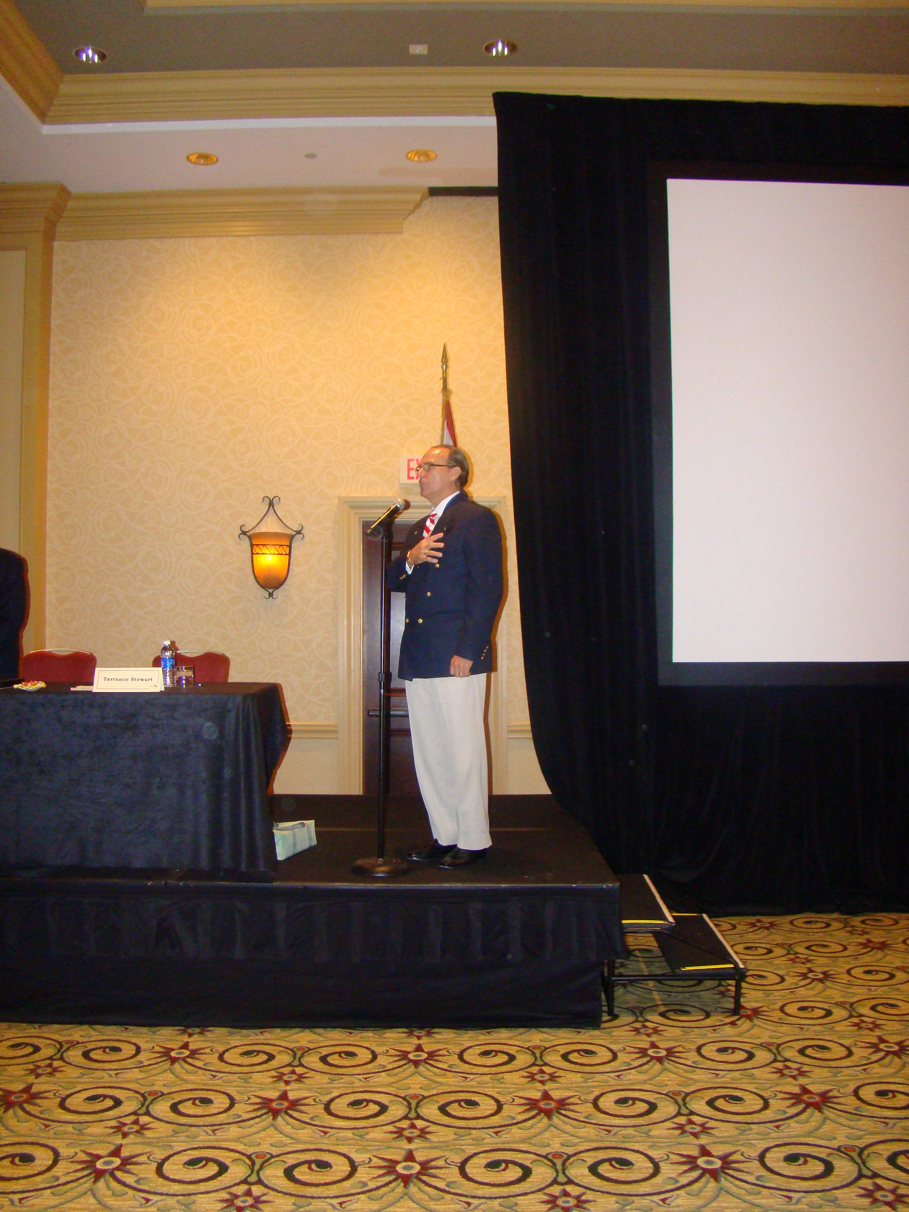
The Bonita Springs Honor Guard kicked off our opening ceremony, followed by our own Terry Stewart singing the National Anthem to a rousing response! The warm greetings from Lee County and the City of Bonita Springs made everyone feel most welcome. Glen Hiemstra opened the conference exploring future trends that will impact our communities and governance; he was thought-provoking! A full day of concurrent sessions followed. The FCCMA Years of Service starting with five years up to 20 years were recognized along with the newly-credentialed managers at the Bright House Networks Reception. On Thursday morning, William Whitson related his experiences during tough times at the Inspirational Breakfast, and Faye Outlaw told us about her journey to the administrator’s office and some of her challenges she’s addressed during Thursday’s Emerging Professional’s Luncheon.

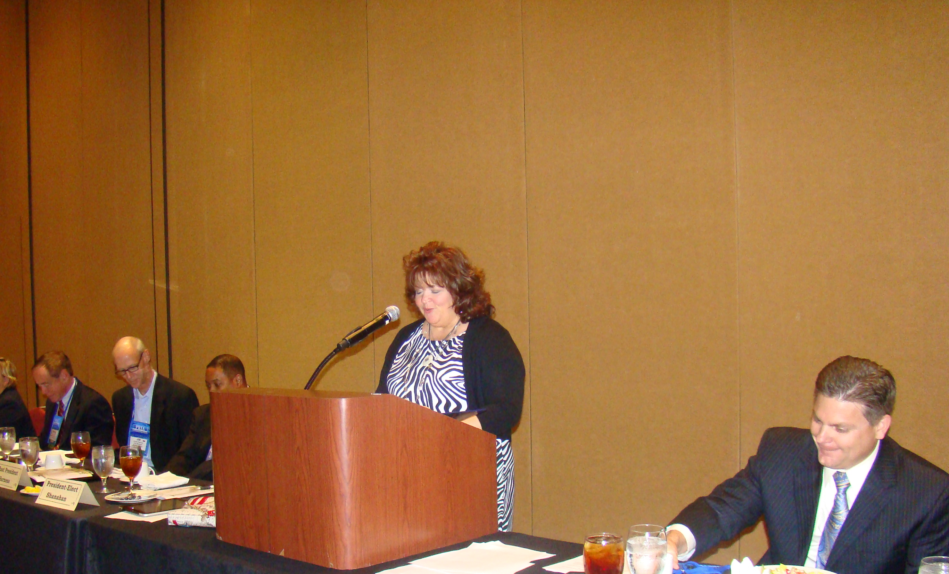
Rob Walker began our day on Friday sharing his successes on telling stories followed by a round of concurrent sessions. The FCCMA voting members approved the new slate of Officers and Directors that will lead us in the new program year. Jon Lewis summed up what had been accomplished in his term as president, and Joyce Shanahan told us what she hopes to accomplish in the coming year. The FCCMA Years of Service from 25 years to 55 years were recognized at the annual awards luncheon. They will be listed in the following article along with the award winners. Two more rounds of concurrent sessions followed the awards luncheon. Friday ended with a networking scavenger hunt and a round of “Association Jeopardy” with a player from each of the eight districts. Bruce Haddock won jeopardy with his knowledge of FCCMA and Ed Mitchell finished in second place.
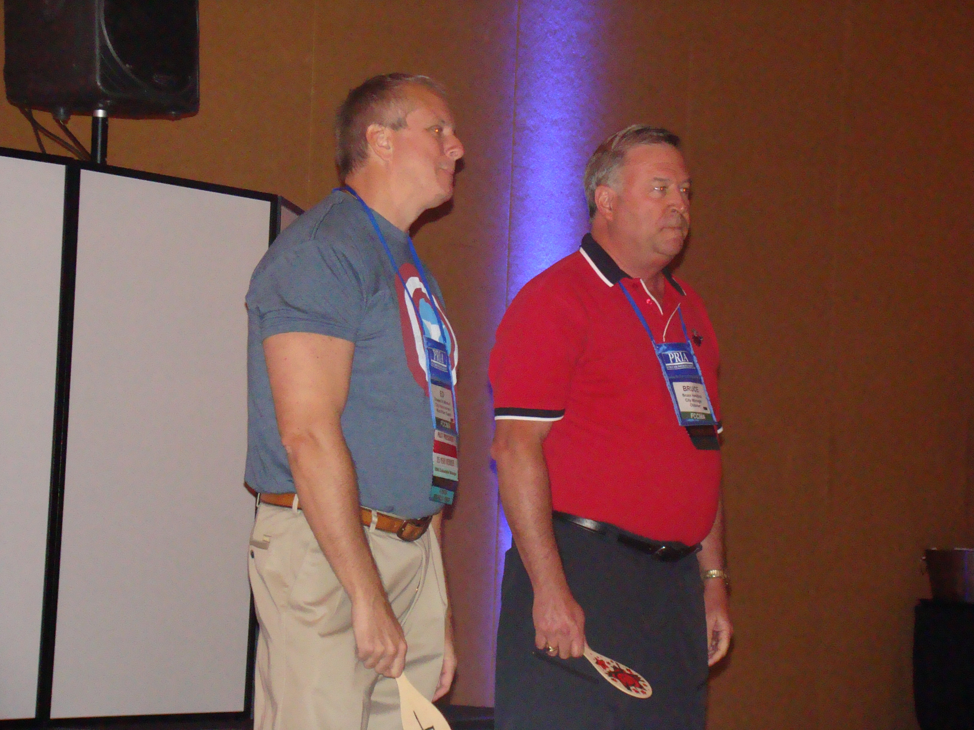
Scott Burrows closed the conference on Saturday morning by sharing his experience on how he went from a FSU football player and winning a kickboxing champion to being diagnosed a quadriplegic. He used his three-pronged formula of vision, mindset and grit to survive and take control. It was a truly amazing story!
The Next Generation of Managers
FCCMA Thanks the 2012 Annual Conference Sponsors

AMEC
Ameresco
American Fidelity Assurance Company
AshBritt Environmental
AXA Equitable
Bright House Networks
CDM Smith
Citrix Systems
Clarke
Colonial Life
Con Edison Solutions
DavenportLawrence
Energy Systems Group
Federated Investors
Fifth Third Securities, Inc.
FirstSouthwest
FL SAFE (Florida Surplus Asset Fund Trust)
Florida Municipal Insurance Trust
Florida Natural Gas Association
Gator Waste & Recycling
Gehring Group
Global Energy Services
Government Services Group, Inc.
GrayRobinson, P.A.
Honeywell
IBM
ICMA Retirement Corp.
Johnson Controls, Inc.
Management Partners
MaxWest Environmental Systems, Inc.
NAPA
Nationwide Retirement Solutions
Preferred Governmental Insurance Trust
Progress Energy
Public Risk Insurance Agency
Questys & Message Vision
SHI International Corp.
Siemens Infrastructure & Cities
Skanska USA Building, Inc.
TECO AFV
Titan America LLC
U.S. Water Services Corporation
Vision Internet
Wade Trim, Inc.
Waste Pro USA, Inc.

Years of Service to FCCMA Awards
Congratulations to the following members for their years of service awards:

5 Years
Jonathan K. Allen
Humberto Alonso
William D. Beasley, P.E.
Paul Berg
M. Michelle Bono
Tom Brzezinski
Hazeline F. Carson
Monica M. Cepero
Christopher E. Cooper
Norton “Mac” Craig
Renee Crichton
Tenny R. Croley
Amy L. Davis
Roberto DiSpirito
John Drury
Jonathan Evans
June Fisher
Caryn Gardner-Young
Nancy G. Gonzalez
Antonio Jefferson
Meridy Kehoe
Bob Koncar
Taryn Kryzda
Jim Landon
William A. “Buck” Lee
Anne S. Lyons
Sandi McKamey
Donald C. Menzel
Jason Nunemaker
Francis J. Porcella
Adam Reichbach
Dan Schlandt
Sally A. Sherman
Gary Shimun
Elithia V. Stanfield
John Mark Taxis
Maryann I. Ustick
Jennifer M. Vigil
Ron E. Williams
Karen Windon
Michael J. Woika

10 Years
Betty Martin Baker
Charles Billias
Kassandra E. Blissett
Marlon C. Brown
Lisa Burley
Michael C. Cernech
Ruby L. Childers
Krisztina Telegdi Ergas
Debalena Fitz-gerald
Robert D. Frank
A.J. Hutson
Shannon Lewis
Vincent S. Long
Andrew D. Lukasik
Deborah S. Manzo
Charlene V. Messer
Caryn Miller
Ivan Pato
Stephen Spratt

15 Years
Russ Blackburn
Robert J. Bradshaw
Michael R. Couzzo, Jr.
James Curry
Elmon Lee Garner
Yocelyn Galiano Gomez
Raoul Lavin
Bruce St. Denis
Richelle M. Sucara
Judy S. Whitis

20 Years
Richard Hood
Howard Kunik

25 Years
Kim Ardila-Morgan
Robert Baldwin
Christopher W. Chinault
Mark E. Durbin
Joanne Hartke
Edward Mitchell
Randall Reid
David R. Sollenberger
Peter J. Witschen
Joseph W. Yarbrough

30 Years
Thomas Bradford
David C. Ritz
Vince Ruano

35 Years
Larry Arnold
Ralph O. Bowers
Allen R. Bush
David T. Harden
Stephen F. Miller
Richard Quigley
R.B. “Chips” Shore

40 Years
Lawrence Casey
Kenneth R. Hammons
Thomas C. Kelly

45 Years
Merrett R. Stierheim

50 Years
Wayne G. Sanborn
Frank R. Spence

55 Years
Anthony Nales

FCCMA Scholarship Winners
2012 B. Harold Farmer Scholarship
Jeff Tillman

2012 Emerging Professionals Conference Scholarship
Scott Andrews
Stephanie Waters

2012 FCCMA Awards

President’s Award
Richard Simmons

If You Care, You Do!
Lee Evett
Shannon Lewis

Pony Express Award
Bud Parmer
Richard Simmons

Michael J. Roberto Award for Career Development
Kenneth Parker
Award for Career Excellence
Merrett Stierheim

Assistant for Excellence in Leadership
Robert Barcinski

Award for Program Excellence
Less Than 20,000
City of Destin

20,001-50,000
City of DeLand

50,001-150,000
City of Boynton Beach

Honorary Membership
Peter Lombardi

Go to www.fccma.org to see the pictures of the award winners.

PY 2012-2013 FCCMA Board of Directors

President
Joyce Shanahan, ICMA-CM
City Manager
City of Ormond Beach

President-Elect
Russ Blackburn
City Manager
City of Gainesville

Secretary/Treasurer
Jill Silverboard, ICMA-CM
Assistant City Manager
City of Clearwater

Past President
Jonathan Lewis, ICMA-CM
City Manager
City of North Port

District I Director
Jeffrey Brown
Assistant City Manager
City of Panama City

District II Director
Michael P. Pleus, ICMA-CM
City Manager
City of DeLand

District III Director
Desiree Matthews
Assistant City Manager
City of Kissimmee

District IV Director
Richard Reade
Sustainability Officer/PIO
City of Delray Beach

District V Director
John Flint
City Manager
City of Weston

District VI Director
Judith Zimomra
City Manager
City of Sanibel

District VII Director
Robert S. LaSala, ICMA-CM
County Administrator
Pinellas County

District VIII Director
Paul A. (Andy) Stewart
Town Manager
Town of Dundee

Directors-At-Large
Robert (Bobby) Green
City Manager
City of Auburndale

Horace A. McHugh, ICMA-CM
Assistant City Manager
City of Oakland Park

Faye W. Outlaw, ICMA-CM
County Administrator
St. Lucie County

FCCMA Members-in-Transition
The following FCCMA members are currently in transition. Please take a minute to show your support by either emailing or phoning the MITs in your district. A phone call or an email can go a long way to help someone who is temporarily out of work.

You can also help if you have any job opportunities or special projects available for which one of our MITs may be qualified. With the current technology, the project could even be done from the MIT’s home. FCCMA staff has many of their resumes. Please contact Carol Russell at crussell@flcities.com if you need a current resume for one of our MITs.

Also, please keep your FCCMA staff informed of any FCCMA members who may be eligible for MIT status. You can email Carol Russell at crussell@flcities.com.

Larry Arnold
District VI
Former Executive Director-
Community Services of Sarasota County
(941) 840-4223
larnoldz@gmail.com

Robert Bartolotta
District VI
Former Manager of Sarasota
(941) 822-0165
savrobert@comcast.net

Robert Bentkofsky
District III
Former Assistant Manager of Oviedo
(407) 971-6125
rlbentkofsky@bellsouth.net

Matthew D. Brock
District III
Former Manager of Polk City
(321) 507-5096
Matt-brock11@hotmail.com

Stephen J. Cottrell
District VII
(727) 487-3763
stcottrell@gmail.com

Michael Czymbor
Former Manager of Fernandina Beach
District II
(904) 310-6182
mczymbor@hotmail.com

Kenneth Fields
Former Manager of Southwest Ranches
District V
(954) 610-7762
krfields@bellsouth.net

Gregory Kisela
Former Manager of Walton County
District I
(850) 333-0816
lgkisela@fairpoint.net

Barbara Lipscomb
Former Manager of Casselberry
District III
(407) 830-7757
Blips50@aol.com

Kathie Margoles
District IV
Former Assistant Manager of Lake Worth
kathiemargoles@bellsouth.net

Jeffrey Naftal
(954) 383-2202
Stout6@bellsouth.net

Frederick C. Nutt
District VII
Former Division Director of Hillsborough County
(813) 792-7811
Fred_libby@msn.com

Markae Rupp
District VIII
Former Administrator of Arcadia
(321) 258-5783
recmngt@gmail.com

Tony Segreto
District II
Former Director of Public Works of Oviedo
(321) 436-7479
tonibuilds@gmail.com

Frank Spence
District IV
Former Manager of Loxahatchee Groves
(561) 640-4908
frspence@bellsouth.net

Susan Stanton
District IV
Former Manager of Lake Worth
(602) 622-0682
susanstanton58@yahoo.com

Bruce St. Denis
District VI
Former Manager of Longboat Key
(941) 650-5054
Saintme53@gmail.com

Donald Stilwell
District VI
Former Manager of Lee County
(239) 334-9301
DDStilwell@embarqmail.com

Dale Sugerman
District IV
Former Manager of Highland Beach
(561) 582-5355
dalesugerman@excite.com

Anita Fain Taylor
District V
Former Manager of Lauderdale Lakes
(954) 854-4240
faintaylor@aol.com

James Titcomb
District IV
Former Manager of North Palm Beach
(561) 315-4302
Jamie@jamestitcomb.com

Ann Toney-Deal
District VIII
Former Manager of Haines City
(863) 422-9242
3anntd@tampabay.rr.com

Oel Wingo
District II
Former Manager of Holly Hill
(386) 299-8755
Owingo50@gmail.com

New Members
The following membership applications have been received. If no current member comes forth with a reason why this applicant should not be approved as a member, they will be invoiced for dues. Michael Bornstein, District IV, City Manager, City of Lake Worth, Full Member; Allison Broihier, District VII, Management Analyst, City of Largo, Affiliate Member; Christine Durrance, District VII, Management Analyst, Town of Belleair, Affiliate Member; and Stuart McCutcheon, District VIII, Master’s of Public Administration, University of Central Florida, Student member.

Positions
The Manager will no longer print the full ad. All ads are posted online at www.fccma.org under job postings. If you click on the job, it will take you to the full ad.

GIS Specialist — Alachua County Board of County Commissioners — $37,779.66 - $60,447.30 annually. Closing Date: 06/22/12. Please apply on-line at http://www.alachuacounty.us/employment. Please direct inquiries regarding this position to (352) 374-5219. Applicants with disabilities will be accommodated in the application process. Preference in initial appointment will be given to eligible veterans and spouses of disabled veterans. ALL OFFERS OF EMPLOYMENT WILL BE CONTINGENT UPON SUCCESSFUL COMPLETION OF A PRE-EMPLOYMENT DRUG TEST. TDD (352) 491-4431. AN EQUAL OPPORTUNITY EMPLOYER M.F.V.D.

City Manager — Archer — Pop. 1200. Application packets must consist of seven (7) copies of the following, a resume with a signed cover letter outlining qualifications, a list of Three (3) professional references and a salary history and requirements. Applications will be accepted until the position is filled. Electronic (e-Mail) applications will not be accepted. Applications may be mailed to 16870 SW 134th Ave. Archer FL 32618. Any questions should be directed to the city manager at 352-495-2880 or e-mailed to citymanager@cityofarcher.com.

Library Services Department Director — Brevard County Board of County Commissioners — Population 536,000. Special Requirement: In the event of hurricane, major storm, natural or man-made disaster that may threaten the area the employee will be required to perform emergency duties as directed. Apply online at www.brevardcounty.us/easy/ by 07/09/2012. EOE/V.

Assistant City Manager for Operations — City of Coral Gables — Salary and benefits package includes: The annual salary range is $102,356.80-$140,545.60. Salary is negotiable depending on qualifications. Benefits include: vehicle allowance of $450 per month, medical, dental and life insurance, retirement plan, leave allowances, and more. Deadline: Open until filled. To ensure consideration for this position, interested candidates should forward resume, cover letter and five references immediately, via e-mail, to HRD@coralgables.com or fax to 305-460-5518. The City of Coral Gables is an Equal Opportunity Employer/Drug Free Workplace.

Building Director, Development Services Department — City of Coral Gables — Salary and benefits package includes: The annual salary range is $92,851.20 - $127,483.20. Salary is negotiable depending on qualifications. Medical, dental and life insurance, leave allowances, retirement plan and more. Deadline: The position shall remain open until filled. To ensure consideration for this position, interested candidates should forward resume, cover letter, current salary, and five references immediately, via e-mail, to HRD@coralgables.com or fax to 305-460-5518. The City of Coral Gables is an Equal Opportunity Employer/Drug Free Workplace.

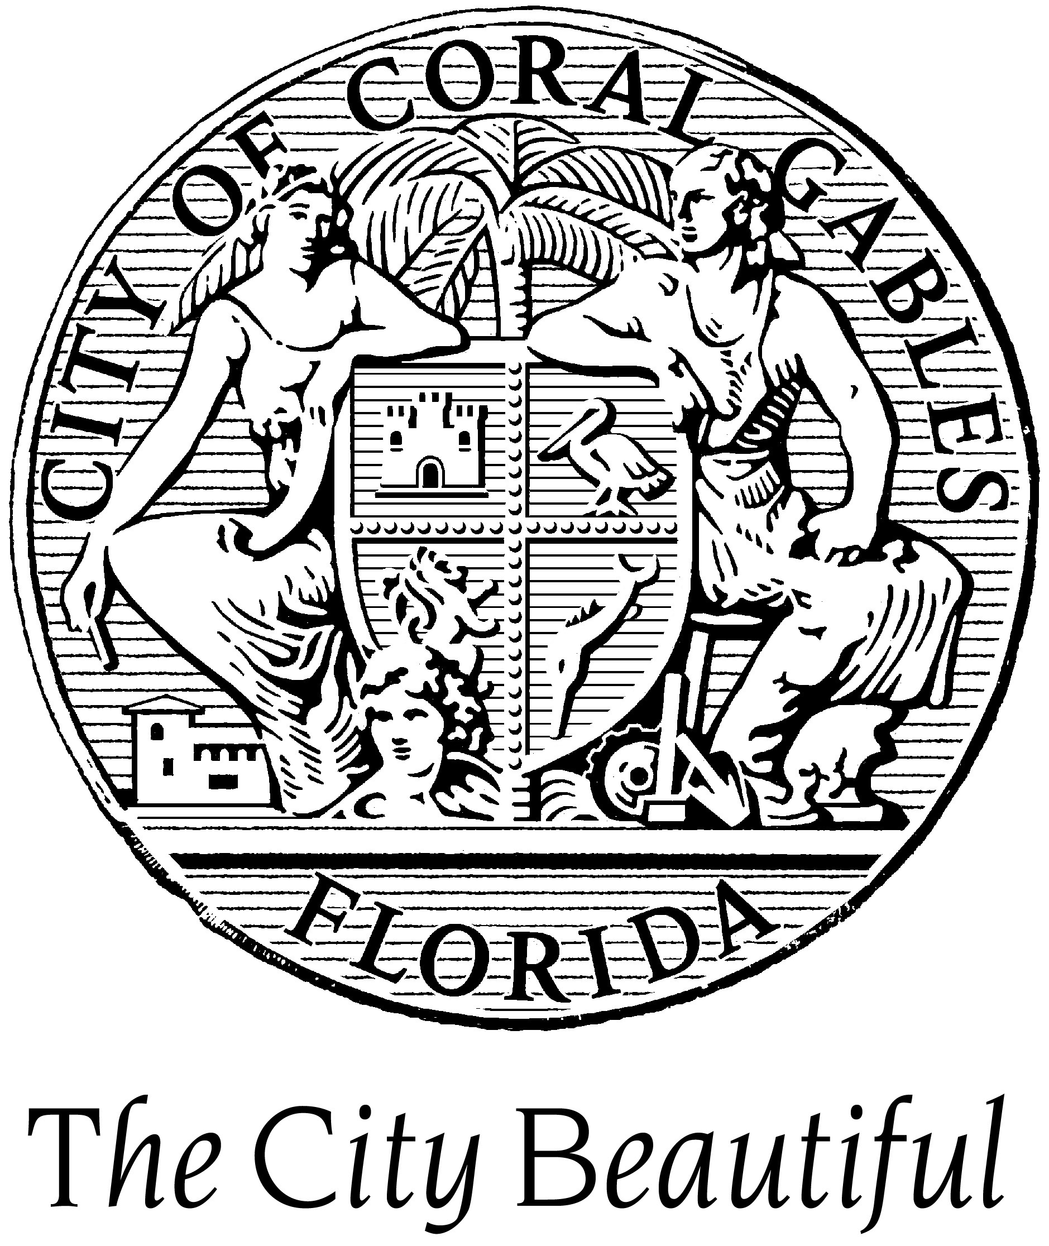
Building Service Coordinator — City of Coral Gables — The annual salary range is $59,862.40- $82,180.80. Salary is negotiable depending on qualifications. Benefits include: Medical, dental, and life insurance, retirement plan, leave allowances, and more. Open until filled. To ensure consideration for this position, interested candidates should forward resume, cover letter, current salary, and five references immediately, via email, to HRD@coralgables.com or fax to 305-460-5518. The City of Coral Gables is an Equal Opportunity Employer/Drug Free Workplace.

Code Enforcement Director — City of Coral Gables — The annual salary range is $65,977.60 to $90,625.60. Salary is negotiable depending on qualifications. Medical, dental and life insurance, leave allowances, retirement plan and more. The position shall remain open until filled. To ensure consideration for this position, interested candidates should forward resume, cover letter, current salary, and five references immediately, via e-mail, to HRD@coralgables.com or fax to 305-460-5518. The City of Coral Gables is an Equal Opportunity Employer/Drug Free Workplace.

Planning and Zoning Director — City of Coral Gables —The annual salary range is $92,851.20 to $127,483.20. Salary is negotiable depending on qualifications. Medical, dental and life insurance, leave allowances, retirement plan and more. The position shall remain open until filled. To ensure consideration for this position, interested candidates should forward resume, cover letter, current salary, and five references immediately, via e-mail, to HRD@coralgables.com or fax to 305-460-5518. The City of Coral Gables is an Equal Opportunity Employer/Drug Free Workplace.

Public Works Director — The City of Coral Gables —The annual salary range is $97,490 to $133,870. Salary is negotiable depending on qualifications. Benefits include: vehicle allowance of $450 per month, medical, dental and life insurance, leave allowances, retirement plan and more. The position shall remain open until filled. To ensure consideration for this position, interested candidates should forward resume, cover letter, current salary, and five references immediately, via e-mail, to HRD@coralgables.com or fax to 305-460-5518. The City of Coral Gables is an Equal Opportunity Employer/Drug Free Workplace.

City Manager — City of Fort Walton Beach, Florida —Salary: The salary range for position is anticipated to be in the $110,000 to $125,000 depending on qualifications. Benefits are competitive. Interested applicants should submit a cover letter, resume, salary and benefit requirements, and five professional references to: City of Fort Walton Beach, Human Resources Department, 107 Miracle Strip Parkway SW, Fort Walton Beach, FL 32548. For additional information, contact the Human Resources Department at (850) 833-9507 or visit our web site at www.fwb.org. Deadline for submittals is July 23, 2012. The City of Fort Walton Beach is an Equal Opportunity Employer.

Financial Management Analyst — City of Green Cove Springs — Starting Salary - $38,310 - $49,800/year. Salary negotiable DOQ&E. Open until filled. Apply To: Personnel Director, 321 Walnut Street, Green Cove Springs, FL 32043; shodges@greencovesprings.com; Phone – (904) 529-2200, Ext. 320. Excellent benefits, including FL State Retirement. Applications accepted Monday – Thursday, 7:00 a.m. to 5:30 p.m. In order to be considered, an application must be submitted, and a resume may be attached. An application may be downloaded at www.greencovesprings.com. Select “Career Opportunities”, then “Employment Application”.

County Attorney — Hillsborough County —Hillsborough County provides a highly competitive compensation package and salary commensurate with experience and qualifications. For optimal consideration, candidates are encouraged to apply early in the process. The closing date for this recruitment is June 25, 2012. Apply via email to apply@ralphandersen.com with a compelling cover letter, comprehensive resume, salary history, and six professional references. Confidential inquiries welcomed to Robert Burg, Ralph Andersen & Associates, (916) 630-4900. For a detailed brochure, please visit www.ralphandersen.com.

Utility Services Director — Indian River County Board of County Commissioners —
(Pop. 138,694) Salary: $78,961 - $118,822 DOQ. Open Until Filled. www.ircgov.com/utility-director.

Senior Building Inspector — Lake County — Hourly Rate: $18.99 - $30.38. Closing Date: Open Until Filled. THIS IS A LIMITED TERM POSITION, DURATION UP TO SEPTEMBER 30, 2012. This position is 32 hours per week. Preference will be given to candidates that possess current Electrical and/or Fire inspector certifications. For more information contact: Jeannine Nelson, Employee Services Specialist at (352) 343-9784.

City Administrator — Lake Helen, Florida — (2,675) Salary: $65,000 - $85,000. Submit resume to City of Lake Helen, P. O. Box 39, Lake Helen, Fla.32744-0039, Attn. City Admin. Application. See City website at lakehelen.com for additional information. Application deadline is 4:30pm July 2, 2012.

Animal Services Director — Marion County — The salary for this position starts at: $60,659.60 - $99,548.80. Open until filled. For more information, contact the Marion County Human Resources Department at (352) 438-2352.

Manager of Applications—Information Technology — City of Melbourne —Hiring Range $51,317 to $86,192/AN. Apply to the Personnel Office, City of Melbourne, 900 E. Strawbridge Avenue, Melbourne FL 32901, or fax to (321) 608-7818. Application available at www.melbourneflorida.org. Equal Opportunity/Veteran’s Preference/Drug-Free Workplace.

City Manager — Mulberry, Florida — The City of Mulberry, Florida is accepting applications for the position of City Manager. Interested applicants are requested to forward their resume to the City of Mulberry, Florida, attention Vanessa Baker, City Clerk, P.O. Box 707, Mulberry, Florida 33860. Applications are due no later than August 1, 2012. Residency in the City limits is required. The salary for the position of City Manager will be in the $60,000 per year range.

Risk Manager — Okaloosa County Board of County Commissioners —Annual Salary Range: $50,128.00 - $67,163.20. To apply for this position, visit our website at www.co.okaloosa.fl.us or call (850) 689-5870 for more information. DFW/AA/EOE.

TDC Executive Director — Okaloosa County Board of County Commissioners — Annual Salary Range: $79,913.60 to $135,824.00. To apply for this position, visit our website at www.co.okaloosa.fl.us or call (850) 689-5870 for more information. This position was first posted on May 3, 2012 and is open until filled. DFW/AA/EOE

Diverse Palm Beach County community seeking qualified individual to fill the position of Grants Writer. Under the general direction of the Town Manager, the purpose of the position is to perform specialized professional work involving researching grant opportunities, preparing grant applications and proposals, to enable the Town to attain its goals and objectives established from time to time by the Town Commission and the Town Manager. Bachelor’s degree from an accredited college or university in Public Administration, Communications, English, Business or related field and a minimum of three years of experience as a grants writer are required. Must have knowledge of federal, state, local and foundation grant application procedures, proven record of securing major grants, excellent writing, speaking and presentation skills, extensive experience in research funding opportunities, knowledge of the principles, concepts, methods and techniques associated with computers and on-line research methods, and the ability to establish and maintain effective relationships with department heads, funding agencies and private organizations. Salary $49,857.50 to $71,662.50 DOQ. Excellent Benefits. Deadline: December 30, 2010 or until the position is closed. Submit current resume and completed Release of Information and Contact Information Form to Human Resources Department, Lake Park Town Hall, 535 Park Avenue, Lake Park, Florida 33403. Release of Information and Contact Information Form may be downloaded from the Employment Opportunities page at the Town’s website at www.lakeparkflorida.gov, and will not be accepted by fax or by email. Phone: 561-881-3300. EOE. Top of Form

Public Works/Utilities Director — City of Opa-locka, FL — Posted Date: 11/23/11. Closing Date: Until filled. Salary: Negotiable. The City offers a competitive salary, an excellent benefits packet, and participates in the Florida Retirement System. To apply please send Resume with cover letter & Official City Application Form to: City of Opa-locka, Human Resources Department, 780 Fisherman Street, Opa-locka, Florida 33054; Tel (305) 953-2815; Fax (305) 953-2919. www.opalockafl.gov. Applications/Resumes for this position will be accepted Monday – Friday 8:30 am – 4:30 pm.

Accounting/Fiscal Services Director — Pasco County, FL — Salary $74,000 - $120,301 annually. Closing date: Continuous. ADA/MF/EOE. Apply online at www.pascocountyfl.net.

Assistant County Administrator – Internal Services — Pasco County, FL — Salary – Negotiable. Closing date: Continuous. ADA/EOE/MF. Apply online at www.pascocountyfl.net.

Assistant County Administrator - Public Services — Pasco County, FL — Salary – Negotiable. Closing date: Continuous. ADA/EOE/MF. Apply online at www.pascocountyfl.net.

Budget Director — Pasco County, FL — Salary: $74,000 - $120,301 annually. Closing date: Continuous. ADA/MF/EOE. Apply online at www.pascocountyfl.net.

Emergency Services Director — Pasco County, FL — Salary: $74,000 - $120,301 annually. Closing Date: Continuous. ADA/MF/EOE. Apply online at www.pascocountyfl.net.

Director of Animal Services — Pinellas County Government, Clearwater, FL — $99,321 - $148,982 + excellent benefits. County application required. Apply by 6/25/2012. Application and additional information available at www.pinellascounty.org under Jobs. AA/EOE/ADA.

Director of Management & Budget — Pinellas County Government, Clearwater, FL — $99,321 - $148,982 + excellent benefits. County application required. Apply by 6/29/2012. Application and additional information available at www.pinellascounty.org under Jobs. AA/EOE/ADA.

General Manager - Facilities, Fleet, Materials Management, Systems and Controls — Sarasota County —Salary and Benefits: $69,992.00 - $100,006.40 (mid-point) May exceed mid-point depending on experience. Excellent benefits include: insurance, leave, state pension, sick child care, wellness programs, exercise facilities, training and much more. For Complete Job Description and To Apply: www.scgov.net/Careers Only applicants that submit an on-line application will be considered. For assistance please call (941) 861-5742. EEO/AA/ADA. Tobacco Free Hiring Policy

General Manager, Transit — Sarasota County — For Info and to Apply: Please see a complete job description and apply on-line at www.scgov.net/Careers. Resumes may be attached. Only applicants that apply on line will be considered. For assistance, please call (941) 861-5742. Salary: $69,992 - $100,006 (midpoint). Salary may exceed mid-point depending on experience. Excellent benefits include training, attractive medical/dental/life insurance, generous paid time off, state retirement program, sick child care, wellness programs and much more. Preference in appointment will be extended to eligible veterans and spouses of veterans with documentation of status (DD-214) at time of application. Sarasota County Government is committed to wellness and successful applicants must be tobacco free for twelve months preceding date of application. Drug Free Work Environment EOE / AA / ADAAA

Director of Tech & Innovation (Chief Information Officer) — City of Tampa — SALARY RANGE: (MJ ) $84,260.80 - $132,163.20 a year. Up to $132,163 depending on qualifications.
TO APPLY: To be considered for this position, applications must be received or postmarked by the closing date of Monday, July 9, 2012. Applications received or postmarked after the closing date will not be processed. HELPFUL HINTS FOR COMPLETING YOUR PPLICATION: Please register as a MyTampaGov member before you begin the application process. This will enable you to view and re-use information from previously submitted applications to complete and submit any future applications. Please make certain your application is complete and the information you provide clearly demonstrates that you possess the minimum job qualifications as stated in the job announcement. Resumes can be submitted in support of an application, but not in lieu of an application. Resumes and copies of certifications or other required documents may be attached to your online application or e-mailed to careers@tampagov.net.
Zoning Official / Code Enforcement Officer / Flood Plain Manager — Town of Yankeetown — Town's Population: 502. Salary: Send proposed salary to employer. Open until filled. You can mail or bring your resume to the Town Hall at 6241 Harmony Lane, Yankeetown, FL 34498.

Dates to Remember:
June 19-22, 2012—FAC Annual Conference, Orlando
August 23-25, 2012—FLC Annual Conference, Hollywood Diplomat
October 7-10, 2012—ICMA Annual Conference, Phoenix, AZ
May 22-25, 2013—FCCMA Annual Conference, Hilton Orlando

